# 2020 Observing Notes

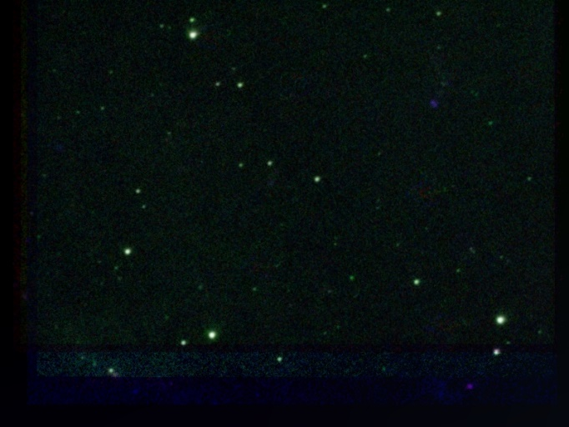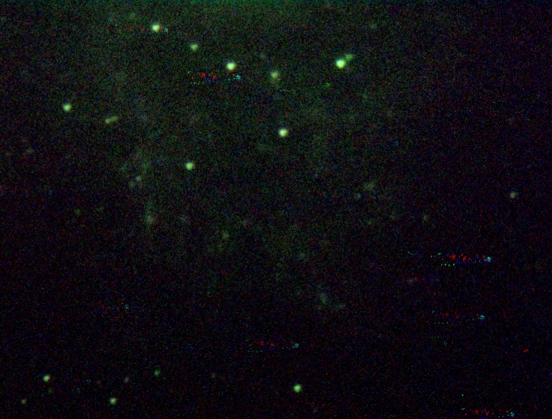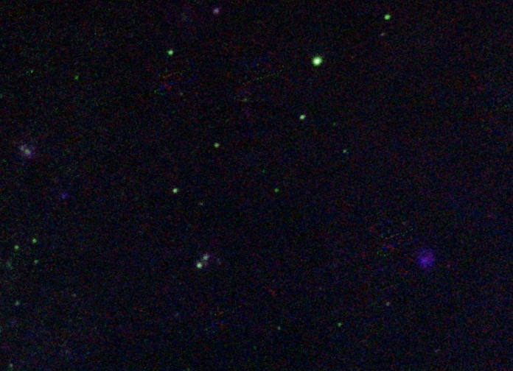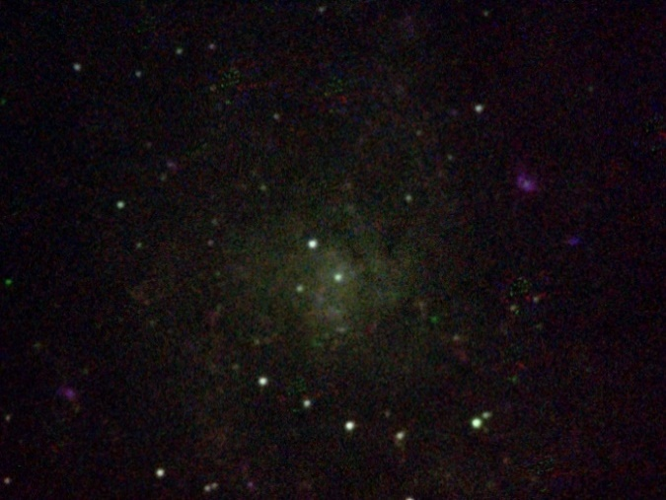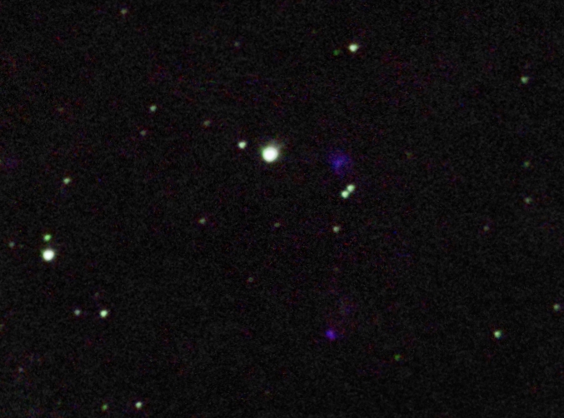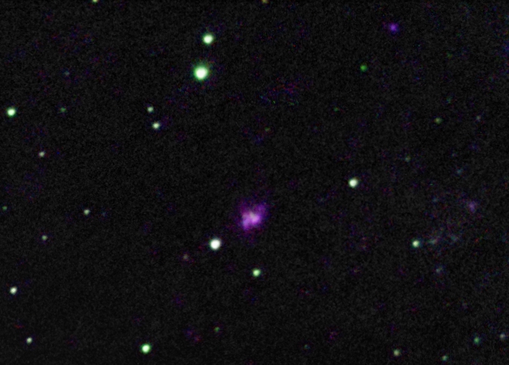

2020 Observing Notes 1

Year in Review 3

January 4

Winter 2020 Planning 4

2020-Jan-04 (Jan-05 UT): M42 Narrowband including NB Continuum 6

2020-Jan-13 (Jan-14 UT): M33 Narrowband including NB Continuum 8

2020-Jan-14 (Jan-15 UT): M33 Narrowband including NB Continuum 9

2020-Jan-15 (Jan-16 UT): M33 Narrowband including NB Continuum 10

2020-Jan-18 (Jan-19 UT): M33 Narrowband including NB Continuum 11

2020-Jan-19 (Jan-20 UT): M33 Narrowband including NB Continuum 12

2020-Jan-23 (Jan-24 UT): Venus and Uranus Video 14

February 16

2020-Feb-02 (Feb-03 UT): Venus and Moon Video 16

March 20

2020-Mar-05 (Mar-06 UT): Venus Video 20

2020-Mar-10 (Mar-11 UT): Venus Video 22

2020-Mar-22 (Mar-23 UT): M42 – Narrow Band Reds 23

2020-Mar-24 (Mar-25 UT): M42 – Narrow Band Reds 24

2020-Mar-30 (Mar-31 UT): Venus and Sirius Video 27

April 28

2020-Mar-31 (Apr-01 UT): Venus and Moon Video 28

References 29

## Year in Review

* TBD

## January

### Winter 2020 Planning

Last Updated 12/31/2019

* Observations – Astro twilight begins around
  + Double Stars Video – **5600mm (C11 w/Barlow); ASI120MM**
    - STF3050AB (HR9074) (new)
    - 36 And (STF73AB) (new)
    - Zet Aqr (STF2909) (new)
    - 53 Aqr (SHJ 345AB) (new)
    - Eta Cas (STF60) (transit 8:00pm)
    - STF3062
    - Iot Cas (StF262Aa-B)
    - Xi Cep (new)
    - STF202 (new)
  + Galaxies
    - **M33** – **2800mm (C11 prime); ST2000XM (binned 2x2?)**
      * Ha regions – Take confirming 486HIB and 501OIII images of a couple of regions at varying radii from the galactic center. Also take continuum images in 467HeII and 540CNT for background subtraction. Goal will be to get quantitative on the O++/H+ abundance
  + Nebulae
    - **M42 – 2800mm (C11 prime); ST2000XM (binned 2x2?)**
      * Need to get blue continuum (467HeII) and green continuum (540CNT) for background subtraction for 486HIB & 501OIII. That will give O++/H+ abundance.
      * Would be great to improve the continuum SNR in the 540 and 467 bands by about a factor of five. So about 15 mins exposure in each.
      * Need to get red continuum (647VIS or 647CNT) for red-regime correction.
      * Try 940NIR and 1000NIR for kicks for NIR stars?
  + Planets
    - **Venus** – **5600mm (C11 w/Barlow); ASI120MM**
      * **Need to get good cloud structure. Be more deliberate in filter selection in the IR and NB if appropriate.**
        + **380NUV – upper clouds**
        + **450BLU – upper clouds – low contrast?**
        + 467HeII (NB Blue) – possible low contrast upper clouds
        + 685NIR – possible better SNR for lower clouds
        + **807NIR – lower clouds or uniform disk**
        + **889CH4 – lower clouds or uniform disk**
        + **940NIR – lower clouds or uniform disk**
        + **1000NIR – lower clouds (day) or surface (night)**
    - **Uranus** – **5600mm (C11 w/Barlow); ASI120MM**
      * Primary goal is to simply capture the brighter polar cap, for that we need 685NIR
      * Secondary goal is to see if any features show in the weaker CH4 bands towards the blue
        + 380NUV – detection threshold only
        + 450BLU
        + **467HeII (NB Blue)**
        + **486HIB (486CH4)**
        + **501OIII (NB Green)**
        + **540CNT (moderate 543CH4)**
        + **685NIR (CH4 reference)**
        + 807NIR – Detection threshold, possible moon detections
  + General code cleanup and consolidation
    - Astrophysical target data codes
    - Observational metadata codes
    - Observational data codes
    - Plot setup codes
    - **Start deleting organic spectroscopic and EW codes**
  + Photometry updates
    - **Numeric output**
    - Catalog data input
    - Response and transformation to standard filters
    - Variable stars and time series plots
    - Blackbody fit and Wein’s law temperature
  + Spectroscopy updates
    - **Make codes, including Vega and M57, more generic**
    - **Blackbody fit and Wein’s law temperature (new code)**
    - Spline fit for normalization (create class or generic routine)
    - Integration into EW Utils
    - **Line-based temperatures (H I and Na II)**
    - Consolidate EW plotting codes, e.g., EW vs line strength or N vs line strength (Jupiter and Vega…)
    - Balmer thermometer?
  + Jupiter spectroscopy and atmospheric vertical modeling – need to wrap up analysis at a clearly documented stopping point.
  + Should figure out what to do with individual star analyses, e.g., Vega, Castor
  + Galaxy composition gradient analysis
    - M31 Multispectral Analysis *ala* M33, M81, M101 etc.
    - Update M81 analysis with new narrowband data
  + Solar Eclipse Movies, ratio analysis, etc.
  + Questions for OPT
    - GoTo Mounts
    - Motorized Focuser

### 2020-Jan-04 (Jan-05 UT): M42 Narrowband including NB Continuum

Last Updated 1/5/2020

Transparency was excellent (4/5) and seeing was good (3/5). Ice started forming on the detector at -10C, so I reset the temperature to +1C. I took biases, darks, and - for the first time with the C11 - flats. (The next day I baked the desiccant plug at 450F for two hours.) All images were binned 2x2 to give a plate scale of about 1.1 arcsec-pix-1. FWHM is worst on the 467HeII images at about 4.7 arcsec (TBC). The other images are more like 3.5 arcsec (TBC).

|  |  |
| --- | --- |
|  |  |
| 20200105UT-467HeII-sum3m30s-Filtered-Log.jpg | M42-20200105UT-540CNT-sum3m30s-Filttered-Log.jpg |
|  |  |
| M42-20200105UT-486HIBsum3m50s-Filtered-Log.jpg | M42-20200105UT-501OIII-sum2m10s-Filtered-Log.jpg |
|  |  |
| M42-20200105UT-656HIA-sum3m30s-Filtered-Log.jpg | M42-20200105UT-501OIIILog-55pct486HIBLog-PureTest.jpg |

|  |  |
| --- | --- |
|  |  |
| M42-20200105UT-486HIBsum3m50s-PureTest-Log.jpg | M42-20200105UT-501OIII-sum2m10s-PureTest-Log.jpg |
|  |  |
| M42-20200105UT-PureConts-Log.jpg | M42-20200105UT-RGB-Pure(Cont-HIB-OIII).jpg |

**Data Disposition:** Raw data is zipped is archived on the 4TB drive. Processed data is in appropriate project directories on the Astronomy SD card.

### 2020-Jan-13 (Jan-14 UT): M33 Narrowband including NB Continuum

Last Updated 1/5/2020

Transparency was excellent (4/5) and seeing was good (3/5). I baked the desiccant and took flats (got the temperature down to -20C) on 2020-Jan-06UT.

Need to note issues with possible use of “all” flats for each filter…

All images were calibrated *without* filtering for hot or dark pixels to better preserve photometric accuracy.

|  |  |
| --- | --- |
|  |  |
| M33-NGC604-20200106UT-XXX-RGB-486-540-501-log.jpg | M33-UNK-20200106UT-XXX-RGB-486-540-501-log.jpg |

**Data Disposition:** Raw data is zipped is archived on the 4TB drive. Processed data is in appropriate project directories on the Astronomy SD card.

### 2020-Jan-14 (Jan-15 UT): M33 Narrowband including NB Continuum

Last Updated 1/5/2020

Transparency was excellent (4/5) and seeing was good (3/5). It appears that patchy clouds affected some of the later exposures, e.g., those on NGC588. When I shut down for the night, I saw some patchy clouds pretty far to the north, but nothing overhead or in any other direction, but in a few of the sub-exposures stars are significantly dimmed.

All images, except the 550OPN ones, were calibrated *without* filtering for hot or dark pixels to better preserve photometric accuracy.

|  |  |
| --- | --- |
|  |  |
| M33-NGC595-20200115UT-XXX-RGB-486-540-501-Log.jpg | M33-NGC588-20200115UT-XXX-RGB-486-540-501-Log.jpg |

**Data Disposition:** Raw data is zipped is archived on the 4TB drive. Processed data is in appropriate project directories on the Astronomy SD card.

### 2020-Jan-15 (Jan-16 UT): M33 Narrowband including NB Continuum

Last Updated 1/5/2020

Transparency was excellent (4/5) and seeing was good (3/5).

|  |  |
| --- | --- |
|  |  |
| M33-UNKB-20200116UT-XXX-RGB-486-540-501-Log.jpg | M33-UNKC-20200116UT-XXX-RGB-486-540-501-Log.jpg |

**Data Disposition:** Raw data is zipped is archived on the 4TB drive. Processed data is in appropriate project directories on the Astronomy SD card.

### 2020-Jan-18 (Jan-19 UT): M33 Narrowband including NB Continuum

Last Updated 1/5/2020

Transparency was excellent (4/5) and seeing was good (3/5).

|  |  |
| --- | --- |
|  |  |
| M33-NGC604-20200119UT-XXX-RGB-486-540-501-Log.jpg | M33-IC132-20200119UT-XXX-RGB-486-540-501-Log.jpg |
|  |  |
| M33-NGC604-20200119UT-550OPN-sum14m10s-Log.jpg | M33-IC132-20200119UT-550OPN-sum9m00s-Log.jpg |

**Data Disposition:** Raw data is zipped is archived on the 4TB drive. Processed data is in appropriate project directories on the Astronomy SD card.

### 2020-Jan-19 (Jan-20 UT): M33 Narrowband including NB Continuum

Last Updated 1/5/2020

Transparency was excellent (4/5) and seeing was good (3/5).

|  |  |
| --- | --- |
|  |  |
| M33-NGC588-20200120UT-XXX-RGB-486-540-501-Log.jpg | M33-UNKC-20200120UT-XXX-RGB-486-540-501-Log.jpg |
|  |  |
| M33-NGC588-20200120UT-550OPN-sum6m20s-Log.jpg | M33-UNKC-20200120UT-550OPN-sum2m50s-BAD-Log.jpg |

|  |  |
| --- | --- |
|  |  |
| M33-UNKB-20200120UT-XXX-RGB-486-540-501-Log.jpg | M33-NGC595-20200120UT-XXX-RGB-486-540-501-Log.jpg |
|  |  |
| M33-UNKB-20200120UT-550OPN-sum7m20s-Log.jpg | M33-NGC595-20200120UT-550OPN-sum7m10s-Log.jpg |

**Data Disposition:** Raw data is zipped is archived on the 4TB drive. Processed data is in appropriate project directories on the Astronomy SD card.

### 2020-Jan-23 (Jan-24 UT): Venus and Uranus Video

Last Updated 1/26/2020

Transparency was mixed (3/5) early with low clouds, but good later (4/5) after clearing. Seeing was very good (4/5) judging by the quality of the Uranus images.

**Venus**

|  |  |  |  |  |  |
| --- | --- | --- | --- | --- | --- |
| **Video File** | **Exposure** | **Gain** | **Gamma** | **Binning** | **Capture Area** |
| 2020-01-24-0051_2-Venus_380NUV.avi | 0.02 | 100 | 50 | 2 | 640x480 |
| 2020-01-24-0052_8-Venus_380NUV.avi | 0.1 | 50 | 50 | 2 | 640x480 |
| 2020-01-24-0156_0-Venus_807NIR.avi | 0.003 | 50 | 50 | 2 | 640x480 |
| 2020-01-24-0158_4-Venus_380NUV_DARK.avi | 0.02 | 100 | 50 | 2 | 640x480 |

|  |  |  |
| --- | --- | --- |
|  |  |  |
| 2020-01-24-0156_0-Venus_807NIR-Stack400-Wavelets3x50-Cont60pct-Crop.png | 2020-01-24-0052_0-Venus_380NUV-Stack600-Wavelets3x10+4x20-Crop.png | 2020-01-24-0124_0-Venus_807NIR-380NUV-Wavelets-Crop.png |

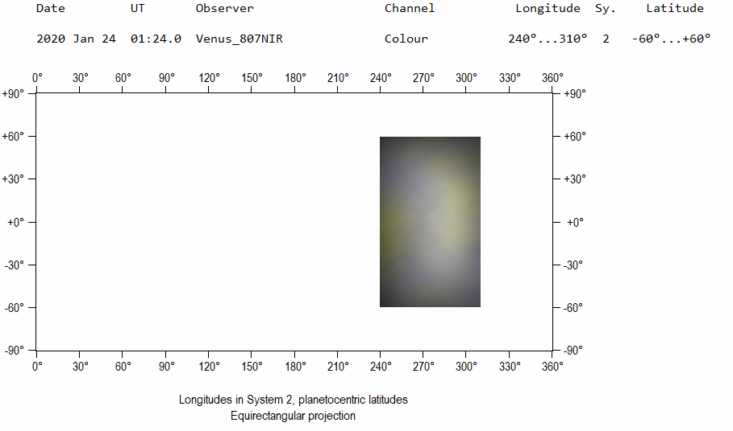

2020-01-24-0124_0-Venus_807NIR-380NUV-MAP.png

For mapping in WinJUPOS, the plate scale was found to be 0.2634 arcsec-pix-1 and the rotation was found to be 354.69 deg.

**Uranus**

|  |  |  |  |  |  |
| --- | --- | --- | --- | --- | --- |
| **Video File** | **Exposure** | **Gain** | **Gamma** | **Binning** | **Capture Area** |
| 2020-01-24-0227_6-Uranus_685NIR.avi | 0.2 | 100 | 50 | 2 | 640x480 |
| 2020-01-24-0228_9-Uranus_685NIR.avi | 0.2 | 100 | 50 | 2 | 640x480 |
| 2020-01-24-0231_6-Uranus_450BLU.avi | 0.05 | 100 | 50 | 2 | 640x480 |
| 2020-01-24-0234_4-Uranus_467HeII.avi | 0.2 | 100 | 50 | 2 | 640x480 |
| 2020-01-24-0239_2-Uranus_807NIR.avi | 0.999 | 100 | 50 | 2 | 640x480 |
| 2020-01-24-0241_9-Uranus_685NIR.avi | 0.2 | 100 | 50 | 2 | 640x480 |
| 2020-01-24-0259_7-Uranus_Dark_50ms.avi | 0.05 | 100 | 50 | 2 | 640x480 |
| 2020-01-24-0300_2-Uranus_Dark_200ms.avi | 0.2 | 100 | 50 | 2 | 640x480 |
| 2020-01-24-0300_8-Uranus_Dark_999ms.avi | 0.999 | 100 | 50 | 2 | 640x480 |

|  |  |  |  |
| --- | --- | --- | --- |
|  |  |  |  |
| 2020-01-24-0239_2-Uranus_807NIR-Stack50-Wavelets3x20-2x-Crop.jpg | 2020-01-24-0236_4-Uranus_685NIR-Stack315-Wavelets2x3+3x3-2x-Crop.jpg | 2020-01-24-0231_6-Uranus_450BLU-Stack600-Wavelets2x40+3x10-Cont60pct-2x-Crop.jpg | 2020-01-24-0234_4-Uranus_467HeII-Stack150-Wavelets3x20-2x-Crop.jpg |
|  |  |  |  |
| 2020-01-24-0235_0-Uranus_685NIR+807NIR-Stack365-Wavelets2x3+3x3-2x-Crop.jpg | 2020-01-24-0234_0-Uranus_685NIRminus40pct450BLU-2x-Crop.png | 2020-01-24-0234_0-Uranus_685NIRminus40pct450BLU-2x-Crop-PseudoColor-CapGrid.PNG |  |

**Data Disposition:** Raw data is zipped is archived on the 4TB drive. Processed data is in appropriate project directories on the Astronomy SD card.

## February

### 2020-Feb-02 (Feb-03 UT): Venus and Moon Video

Last Updated 2/04/2020

Transparency was excellent (4/5) and seeing was very, very good (4+/5).

**Venus**

I took lots of video tonight and built images out of about the top 15% of frames. Seeing was very good. All binning was 1x1 except for 889CH4, 940NIR, and 380NUV. I could have gotten many more frames if I’d gone down to 320x240 sub-framing.

I captured detail in the NUV that is verified by images on JALPO taken about 6 and 12 hours earlier. I had hoped to capture NIR detail, but at best it is very low contrast and shows only large spatial scales.

I’ve tried a few processing techniques that need to be explored more thoroughly. First, I tried unsharp masking in MaximDL. That definitely brought out detail in the NUV and seemed not to over-enhance the limb. Second, I tried limb darkening correction in WinJUPOS. This seems to provide detail enhancement, but there appears to be no way to save the images other than making a map with them. Third, and I’ve done this before, dividing the NUV by the NIR images.

|  |  |  |  |  |  |
| --- | --- | --- | --- | --- | --- |
| **Video File** | **Exposure** | **Gain** | **Gamma** | **Binning** | **Capture Area** |
| 2020-02-03-0034_7-Venus_807NIR.avi | 0.004 | 50 | 50 | 1 | 640x480 |
| 2020-02-03-0036_9-Venus_807NIR.avi | 0.004 | 50 | 50 | 1 | 640x480 |
| 2020-02-03-0037_9-Venus_807NIR.avi | 0.004 | 50 | 50 | 1 | 640x480 |
| 2020-02-03-0040_1-Venus_889CH4.avi | 0.05 | 50 | 50 | 1 | 640x480 |
| 2020-02-03-0042_1-Venus_889CH4.avi | 0.05 | 50 | 50 | 1 | 640x480 |
| 2020-02-03-0044_8-Venus_940NIR.avi | 0.05 | 50 | 50 | 2 | 640x480 |
| 2020-02-03-0046_8-Venus_940NIR.avi | 0.05 | 50 | 50 | 2 | 640x480 |
| 2020-02-03-0049_4-Venus_685NIR.avi | 0.001 | 50 | 50 | 1 | 640x480 |
| 2020-02-03-0050_5-Venus_685NIR.avi | 0.001 | 50 | 50 | 1 | 640x480 |
| 2020-02-03-0058_9-Venus_380NUV.avi | 0.03 | 50 | 50 | 2 | 640x480 |
| 2020-02-03-0059_9-Venus_380NUV.avi | 0.03 | 50 | 50 | 2 | 640x480 |
| 2020-02-03-0101_0-Venus_380NUV.avi | 0.03 | 50 | 50 | 2 | 640x480 |
| 2020-02-03-0102_0-Venus_380NUV.avi | 0.03 | 50 | 50 | 2 | 640x480 |
| 2020-02-03-0103_1-Venus_380NUV.avi | 0.03 | 50 | 50 | 2 | 640x480 |
| 2020-02-03-0104_1-Venus_380NUV.avi | 0.03 | 50 | 50 | 2 | 640x480 |
| 2020-02-03-0105_2-Venus_380NUV.avi | 0.03 | 50 | 50 | 2 | 640x480 |
| 2020-02-03-0106_2-Venus_380NUV.avi | 0.03 | 50 | 50 | 2 | 640x480 |
| 2020-02-03-0107_3-Venus_380NUV.avi | 0.03 | 50 | 50 | 2 | 640x480 |
| 2020-02-03-0108_3-Venus_380NUV.avi | 0.03 | 50 | 50 | 2 | 640x480 |

|  |  |  |  |
| --- | --- | --- | --- |
|  |  |  |  |
| 940  2020-02-03-0045_8-Venus_940NIR-Stack800-Wavelets2x15+3x10-2X-Derotated.png | 889  2020-02-03-0041_1-Venus_889CH4-Stack800-Wavelets3x20+4x10-Str0to128-Derotated.png | 807  2020-02-03-0036_5-Venus_807NIR-Stack1500-Wavelets2x20+3x10-Derotated.png | 685  2020-02-03-0050_0-Venus_685NIR-Stack1000-Wavelets3x20+4x20-Derotated.png |
|  |  |  |  |
| 380  2020-02-03-0103_6-Venus_380NUV-Stack3000-Wavelets3x40-Str0to128-2X-Wavelets5x20-Derotated.png | 380  2020-02-03-0103_6-Venus_380NUV-Stack3000-Wavelets3x40-Str0to128-2X-Wavelets5x20-Derotated-Unsharp.png | NUV/ALLNIR  2020-02-03-0053_4-Venus_NUVoverALLNIR-Derotated.png | RGB  2020-02-03-0050_1-Venus-Hill-807-Synth-380-R(G)B.png |

**Moon**

|  |  |  |  |  |  |  |  |  |  |  |
| --- | --- | --- | --- | --- | --- | --- | --- | --- | --- | --- |
| **Video File** | | **Exposure** | **Gain** | | | **Gamma** | | **Binning** | | **Capture Area** |
| 2020-02-03-0221_1-Moon_685NIR.avi  Posidonius | 0.015 | | | 50 | 50 | | 1 | | 1280x960 | |
| 2020-02-03-0222_1-Moon_685NIR.avi  Posidonius | 0.015 | | | 50 | 50 | | 1 | | 1280x960 | |
| 2020-02-03-0226_8-Plato_685NIR.avi  Plato | 0.03 | | | 50 | 50 | | 1 | | 1280x960 | |
| 2020-02-03-0227_9-Plato_685NIR.avi  Plato | 0.03 | | | 50 | 50 | | 1 | | 1280x960 | |
| 2020-02-03-0229_7-Plato_685NIR.avi  Montes Teneriffe | 0.03 | | | 50 | 50 | | 1 | | 1280x960 | |
| 2020-02-03-0230_7-Plato_685NIR.avi  Montes Teneriffe | 0.03 | | | 50 | 50 | | 1 | | 1280x960 | |
| 2020-02-03-0232_5-Moon_685NIR.avi  Archimedes | 0.03 | | | 50 | 50 | | 1 | | 1280x960 | |
| 2020-02-03-0234_4-Moon_685NIR.avi  Eratosthenes | 0.03 | | | 50 | 50 | | 1 | | 1280x960 | |
| 2020-02-03-0237_0-Moon_685NIR.avi  Copernicus | **0.05** | | | 50 | 50 | | 1 | | 1280x960 | |
| 2020-02-03-0239_8-Moon_685NIR.avi  Rupes Recta | 0.03 | | | 50 | 50 | | 1 | | 1280x960 | |
| 2020-02-03-0243_2-Moon_685NIR.avi  Pitatus | 0.03 | | | 50 | 50 | | 1 | | 1280x960 | |
| 2020-02-03-0246_0-Moon_685NIR.avi  Rima Hyginus | 0.03 | | | 50 | 50 | | 1 | | 1280x960 | |
| 2020-02-03-0247_9-FlatWGradient_685NIR.avi | 0.03 | | | 50 | 50 | | 1 | | 1280x960 | |

|  |  |
| --- | --- |
|  |  |
| POSIDONIUS  2020-02-03-0221_6-Moon_685NIR-Stack300-Crater-Wavelets2x30+3x20-Wavelets.png | PLATO  2020-02-03-0227_3-Plato_685NIR-Stack300-1pt-Wavelets2x30+3x20-Gam150pct-Wavelets.png |
|  |  |
| MONTES TENERIFFE  2020-02-03-0230_2-Plato_685NIR-Stack300-Wavelets2x20+3x20-Gam150pct-Wavelets-Gam.png | ARCHIMEDES  2020-02-03-0232_5-Moon_685NIR-Stack150-Wavelets2x30+3x30.png |
|  |  |
| ERATOSTHENES  2020-02-03-0234_4-Moon_685NIR-Stack150-Wavelets2x30+3x20-Crater.png | ARCHIMEDES  2020-02-03-0232_5-Moon_685NIR-Stack150-Wavelets2x30+3x30.png |

|  |  |
| --- | --- |
|  |  |
| COPERNICUS  2020-02-03-0237_0-Moon_685NIR-Stack150-Wavelets2x30+3x20-Gam150pct.png | RUPES RECTA  2020-02-03-0239_8-Moon_685NIR-Stack150-Crater-Wavelets2x30+3x20-Gam150pct.png |
|  |  |
| PITATUS  2020-02-03-0243_2-Moon_685NIR-Stack150-Wavelets2x10+3x20-Gam150pct.png | RIMA HYGINUS  2020-02-03-0246_0-Moon_685NIR-Stack150-Crater-Wavelets2x30+3x20.png |

**Data Disposition:** Raw data is zipped is archived on the 4TB drive. Processed data is in appropriate project directories on the Astronomy SD card.

## March

### 2020-Mar-05 (Mar-06 UT): Venus Video

Last Updated 3/05/2020

A very clear night with transparency 3.5/5 because there were a couple of contrails. Seeing was very good at 4/5.

|  |  |  |  |
| --- | --- | --- | --- |
|  |  |  |  |
| 2020-03-06-0144_4-Venus_940NIR-Derotated.png | 2020-03-06-0138_3-Venus_889CH4-Derotated.png | 2020-03-06-0133_9-Venus_807NIR-Derotated.png | 2020-03-06-0131_0-Venus_685NIR-Derotated.png |
|  |  |  |  |
| 2020-03-06-0117_7-Venus_380NUV-Derotated.png |  |  | RGB  2020-02-03-0050_1-Venus-Hill-807-Synth-380-R(G)B.png |

|  |  |  |  |  |  |
| --- | --- | --- | --- | --- | --- |
| **Video File** | **Exposure** | **Gain** | **Gamma** | **Binning** | **Capture Area** |
| 2020-03-06-0110_3-Venus_380NUV.avi | 0.05 | 50 | 50 | 2 | 640x480 |
| 2020-03-06-0112_3-Venus_380NUV.avi | 0.05 | 50 | 50 | 2 | 640x480 |
| 2020-03-06-0114_5-Venus_380NUV.avi | 0.05 | 50 | 50 | 2 | 640x480 |
| 2020-03-06-0116_6-Venus_380NUV.avi | 0.05 | 50 | 50 | 2 | 640x480 |
| 2020-03-06-0118_7-Venus_380NUV.avi | 0.05 | 50 | 50 | 2 | 640x480 |
| 2020-03-06-0120_8-Venus_380NUV.avi | 0.05 | 50 | 50 | 2 | 640x480 |
| 2020-03-06-0123_0-Venus_380NUV.avi | 0.05 | 50 | 50 | 2 | 640x480 |
| 2020-03-06-0125_2-Venus_380NUV.avi | 0.05 | 50 | 50 | 2 | 640x480 |
| 2020-03-06-0130_3-Venus_685NIR.avi | 0.001 | 50 | 50 | 1 | 320x240 |
| 2020-03-06-0130_6-Venus_685NIR.avi | 0.001 | 50 | 50 | 1 | 320x240 |
| 2020-03-06-0131_0-Venus_685NIR.avi | 0.001 | 50 | 50 | 1 | 320x240 |
| 2020-03-06-0131_3-Venus_685NIR.avi | 0.001 | 50 | 50 | 1 | 320x240 |
| 2020-03-06-0131_7-Venus_685NIR.avi | 0.001 | 50 | 50 | 1 | 320x240 |
| 2020-03-06-0132_5-Venus_807NIR.avi | 0.003 | 50 | 50 | 1 | 320x240 |
| 2020-03-06-0133_0-Venus_807NIR.avi | 0.003 | 50 | 50 | 1 | 320x240 |
| 2020-03-06-0133_3-Venus_807NIR.avi | 0.003 | 50 | 50 | 1 | 320x240 |
| 2020-03-06-0133_6-Venus_807NIR.avi | 0.003 | 50 | 50 | 1 | 320x240 |
| 2020-03-06-0134_6-Venus_807NIR.avi | 0.003 | 50 | 50 | 1 | 320x240 |
| 2020-03-06-0134_9-Venus_807NIR.avi | 0.003 | 50 | 50 | 1 | 320x240 |
| 2020-03-06-0135_2-Venus_807NIR.avi | 0.003 | 50 | 50 | 1 | 320x240 |
| 2020-03-06-0137_2-Venus_889CH4.avi | 0.003 | 50 | 50 | 1 | 320x240 |
| 2020-03-06-0138_2-Venus_889CH4.avi | 0.02 | 50 | 50 | 2 | 320x240 |
| 2020-03-06-0139_3-Venus_889CH4.avi | 0.02 | 50 | 50 | 2 | 320x240 |
| 2020-03-06-0141_3-Venus_940NIR.avi | 0.02 | 50 | 50 | 2 | 320x240 |
| 2020-03-06-0143_4-Venus_940NIR.avi | 0.05 | 50 | 50 | 2 | 640x480 |
| 2020-03-06-0145_4-Venus_940NIR.avi | 0.05 | 50 | 50 | 2 | 640x480 |
| 2020-03-06-0147_5-Venus_940NIR.avi | 0.05 | 50 | 50 | 2 | 640x480 |

**Data Disposition:** Raw data is zipped is archived on the 4TB drive. Processed data is in appropriate project directories on the Astronomy SD card.

### 2020-Mar-10 (Mar-11 UT): Venus Video

Last Updated 3/12/2020

A very clear night with transparency 3.5/5. Seeing was poor at 2/5, but I wanted to try out the 1000nm filter.

|  |  |  |
| --- | --- | --- |
|  |  |  |
| 2020-03-11-0103_3-Venus_1000NIR-Derotated.png | 2020-03-11-0108_1-Venus_807NIR-Derotated.png | 2020-03-11-0110_5-Venus_685NIR-Derotated.png |
|  |  |  |
| 2020-03-11-0121_9-Venus_380NUV-Derotated.png |  | 2020-03-11-0116_2-Venus-Hill-NUV-685-R(G)B.png |

|  |  |  |  |  |  |
| --- | --- | --- | --- | --- | --- |
| **Video File** | **Exposure** | **Gain** | **Gamma** | **Binning** | **Capture Area** |
| 2020-03-11-0101_6-Venus_1000NIR.avi | 0.05 | 50 | 50 | 1 | 640x480 |
| 2020-03-11-0103_6-Venus_1000NIR.avi | 0.02 | 50 | 50 | 2 | 640x480 |
| 2020-03-11-0104_7-Venus_1000NIR.avi | 0.02 | 50 | 50 | 2 | 640x480 |
| 2020-03-11-0107_6-Venus_807NIR.avi | 0.005 | 50 | 50 | 1 | 640x480 |
| 2020-03-11-0108_6-Venus_807NIR.avi | 0.005 | 50 | 50 | 1 | 640x480 |
| 2020-03-11-0110_0-Venus_685NIR.avi | 0.001 | 50 | 50 | 1 | 640x480 |
| 2020-03-11-0111_1-Venus_685NIR.avi | 0.001 | 50 | 50 | 1 | 640x480 |
| 2020-03-11-0116_7-Venus_380NUV.avi | 0.05 | 50 | 50 | 2 | 640x480 |
| 2020-03-11-0118_7-Venus_380NUV.avi | 0.05 | 50 | 50 | 2 | 640x480 |
| 2020-03-11-0120_8-Venus_380NUV.avi | 0.05 | 50 | 50 | 2 | 640x480 |
| 2020-03-11-0123_0-Venus_380NUV.avi | 0.05 | 50 | 50 | 2 | 640x480 |
| 2020-03-11-0125_1-Venus_380NUV.avi | 0.05 | 50 | 50 | 2 | 640x480 |
| 2020-03-11-0127_2-Venus_380NUV.avi | 0.05 | 50 | 50 | 2 | 640x480 |

**Data Disposition:** Raw data is zipped is archived on the 4TB drive. Processed data is in appropriate project directories on the Astronomy SD card.

### 2020-Mar-22 (Mar-23 UT): M42 – Narrow Band Reds

Last Updated 3/12/2020

A very clear night with transparency 4/5. Seeing was fair at 3/5.

|  |  |
| --- | --- |
|  |  |
| M42-20200323UT-647CNT-sum3m30sLog.jpg | M42-20200323UT-656HIA-sum3m20s-Log.jpg |
|  |  |
| M42-20200323UT-658NII-sum2m40s-Log.jpg | M42-20200323UT-672SII-sum3m20s-log.jpg |

### 2020-Mar-24 (Mar-25 UT): M42 – Narrow Band Reds

Last Updated 3/26/2020

A clear night with transparency 3/5. Seeing was fair at 3/5.

|  |  |
| --- | --- |
|  |  |
| M42-20200325UT-647CNT-sum12m50s-log.jpg | M42-20200325UT-656HIA-sum5m10s-log.jpg |
|  |  |
| M42-20200325UT-658NII-sum5m10s-log.jpg | M42-20200325UT-672SII-sum11m10s-log.jpg |

|  |  |
| --- | --- |
|  |  |
| M42-2020032XUT-647CNT-sum16m40s-Log.jpg | M42-2020032XUT-656HIA-sum8m30s-Log.jpg |
|  |  |
| M42-2020032XUT-658NII-sum7m50s-Log.jpg | M42-2020032XUT-672SII-sum14m30s-log.jpg |

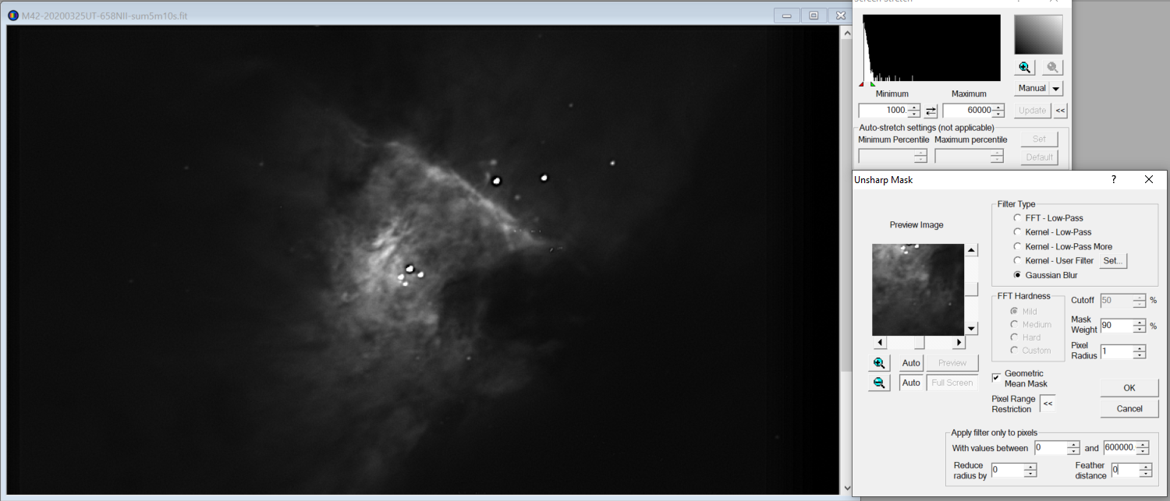

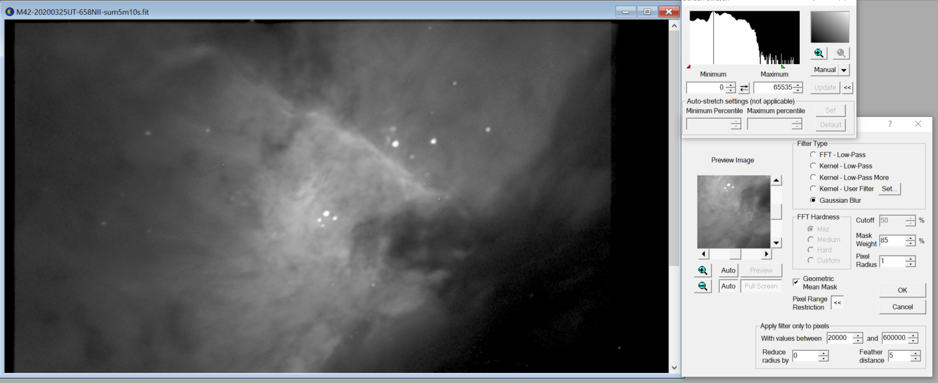

### 2020-Mar-30 (Mar-31 UT): Venus and Sirius Video

Last Updated 3/12/2020

A clear night with transparency 4/5. Seeing was fair to good at 3/5.

## April

### 2020-Mar-31 (Apr-01 UT): Venus and Moon Video

Last Updated 3/05/2020

A clear night with transparency 4/5. Seeing was fair to good at 3/5.

## References